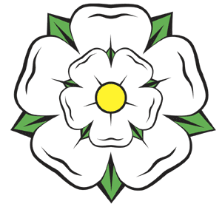

##### YORKSHIRE FOLK DANCE WEEKEND

### *10th Event*

**4th, 5th & 6th July 2025**

***Friday evening to Sunday afternoon***

### Drax, Yorkshire

*between Selby (North Yorkshire) and Goole (East Yorkshire)*

*Our invited guests are:*

**Callers: Geoff Cubitt, Bernie Culkin,**

#### Musicians: Fran Bulpit, Philip Rowe &

#### Dave Yeomans

More info and book online via the website https://yfdw.org.uk

Email: yfdw.drax@gmail.com

